pwd - gives the present working directory which you resides.



vi - syntax : vi filename

Creates a new file if it already does not exist, otherwise opens an existing file.

Creating Vi file.txt ------------

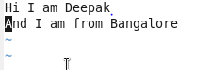

TO exit from vi editor enter ---- > esc + wq!

touch - used to create an empty file.

ex: touch hello.

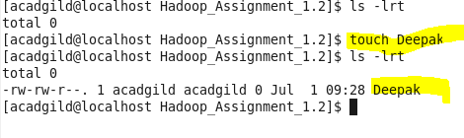

**Mkdir**:

Used to create a new directory.

Mkdir Hadoop_Assignment_1.2

**Cd** :

Used to change the directory to desired one from present working directory.

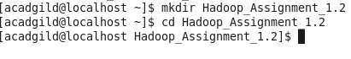

**Rm:**

To remove files and directories.

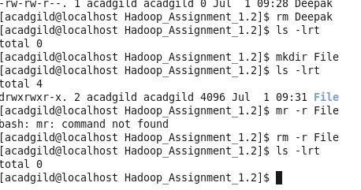

**Ls:**

Used to list the files and directories under it.



**Echo :**

Used to outputs the strings it is being passed as arguments. It is just like printf statement in c++.



**Cat:**

Used to create single or multiple files, view contain of file, concatenate files and redirect output.

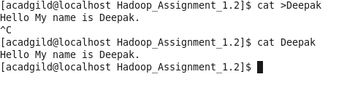

**Who:**

Displays a list of users who are currently logged into the computer

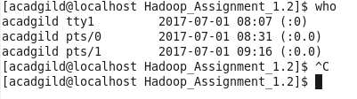

**date**

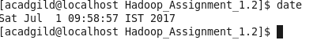

**Cal:**

Outputs the calendar of the month

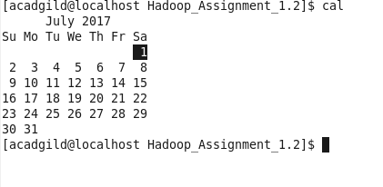

**Mv:**

To move the files from source to destination

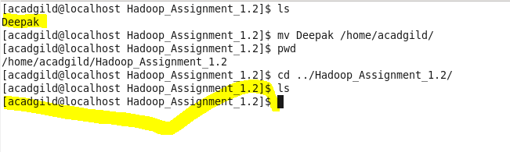

**Cp:**

To copy files from source to destination

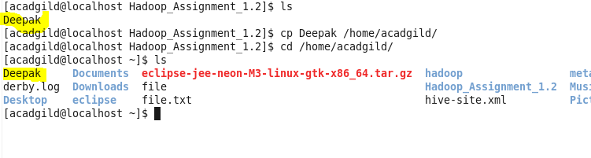

Which:

used to identify the location of executables